# Creating Certificate for Office Web App Server

1. Create cert request (CRS) Using the digicert util <https://www.digicert.com/util/>
   * Certificate Type - SSL
   * Common Name – can be whatever just remember it (owascert)
   * Subject Alternative Names (SAN) – use InternalURL and ExternalURL used in the OWA server set up
     + owas.healthequity.com
     + sab01spo01.heq.corp.he
   * Organization – HealthEquity
   * Department – Collaboration Management
   * City – Draper
   * State – Utah
   * Country – USA
   * Key Size – 2048
2. Copy cert request and send to the SRE team to complete
   * It should look like this:

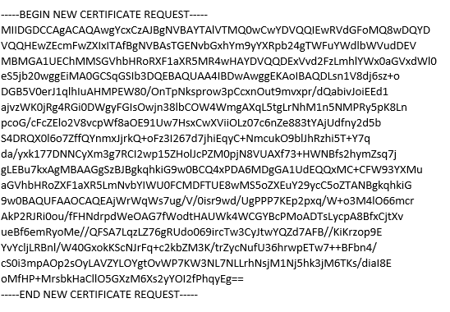

1. SRE team will complete and sent a .cer file back to you
2. Open Internet Information Services (IIS) in the web server
3. Click Server name in the connections then double-click on Server Certificates in the middle pane
4. Click on Complete Certificate Request in the Actions panel
5. Add the .cer file received from SRE and add a friendly name. Note: It will not let you use a previously used certificate friendly name
6. Set the cert store to Personal and click OK